Assignment

use hr_db databases accordingly.

**1) find the details of the employees who have joined before their managers.**

SELECT e.employee_id as eID, CONCAT(e.first_name , " ", e.last_name) as EmployeeName, e.email, e.hire_date as EmpHireDate, m.hire_date as ManagerHireDate

FROM employees as e JOIN employees as m ON e.manager_id = m.employee_id

WHERE e.hire_date < m.hire_date ;

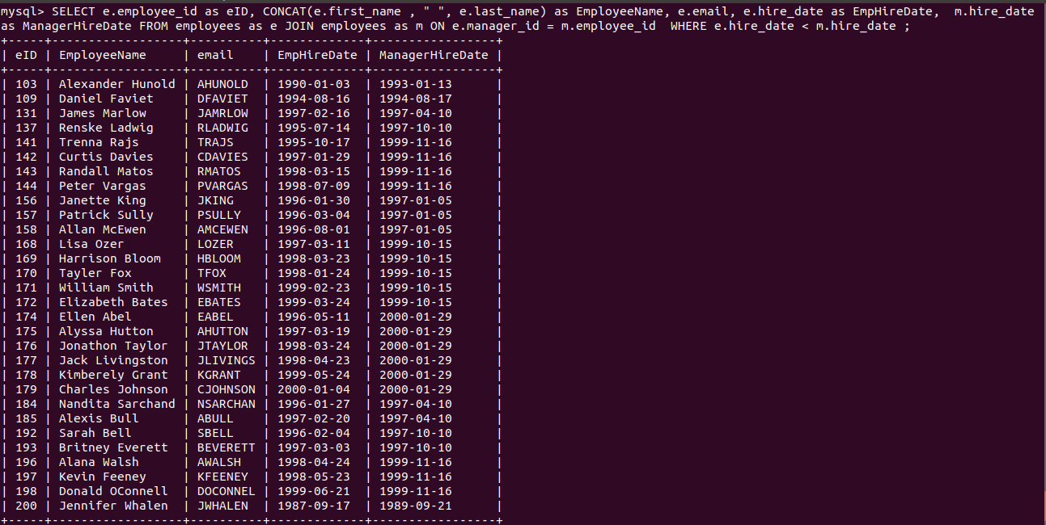

**2) how many employees join every year.**

SELECT YEAR(hire_date) as JoiningYear, COUNT(*)

FROM employees GROUP BY JoiningYear;

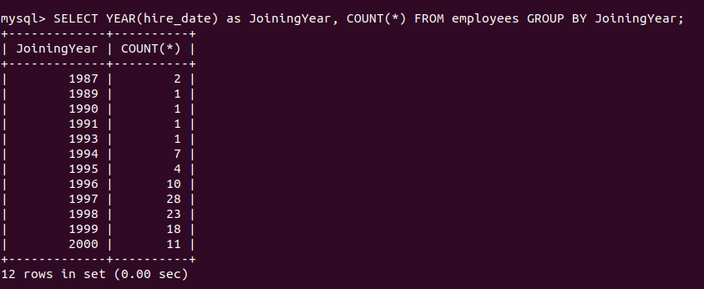

**3) Display the complete address(including region name and country name) of every department.**

SELECT d.department_id, d.department_name, l.location_id, c.country_name , r.region_name FROM departments as d JOIN locations as l ON d.location_id = l.location_id

JOIN countries as c ON l.country_id = c.country_id

JOIN regions as r ON c.region_id = r.region_id;

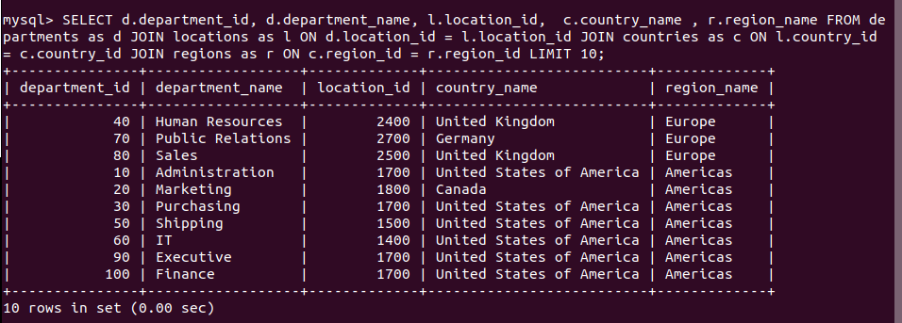

**4) find the order placed between year 2004 and 2005**

SELECT orderNumber, YEAR(orderDate) as OrderYear

FROM orders

WHERE YEAR(orderDate) BETWEEN 2004 AND 2005;

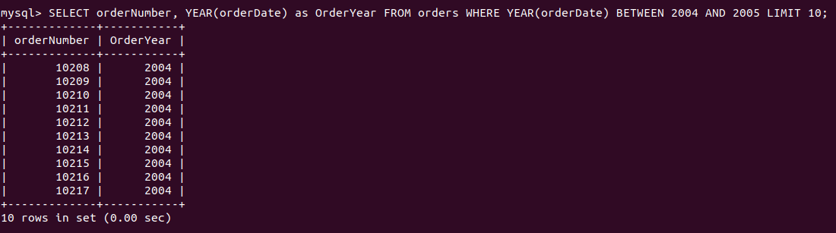

**5) Write a query to display the first day of the month (in datetime format) three months before the current month.**

**Sample current date : 2014-09-03**

**Expected result : 2014-06-01**

SELECT date(((PERIOD_ADD

(EXTRACT(YEAR_MONTH

FROM CURDATE()),-3)*100)+1));

**6) Write a query to display the last day of the month (in datetime format) three months before the current month.**

SELECT (SUBDATE(DATE

(CURDATE(),INTERVAL 3 MONTH),

INTERVAL DAYOFMONTH(CURDATE())DAY))

AS LastDayOfTheMonth;

**7) Write a query to get the distinct Mondays from hire_date in employees tables**

SELECT DISTINCT(STR_TO_DATE(CONCAT(YEARWEEK(hire_date),'1'),'%x%v%w')) as Mondays FROM employees

ORDER BY Mondays asc;

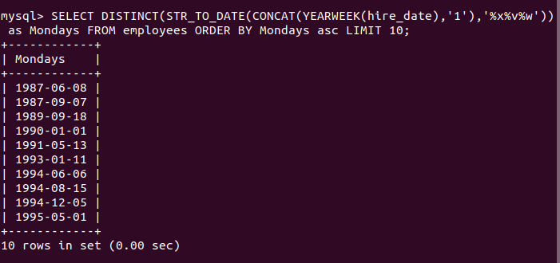

**8) Write a query to get the first name, last name who joined in the month of June**

SELECT first_name, last_name , hire_date

FROM employees

WHERE MONTH(hire_date) = 6;

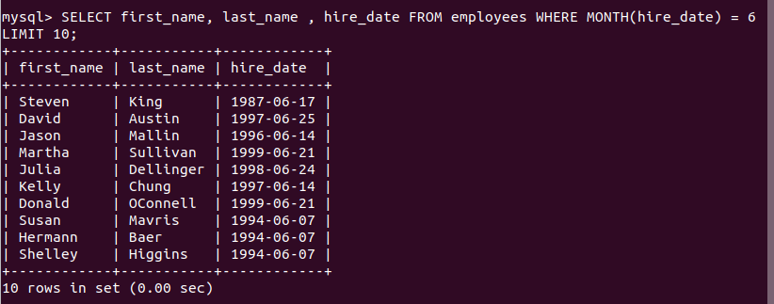

**9) Write a query to get the years in which more than 10 employees joined.**

